Smart Campus Navigation

Introduction
This comprehensive report integrates all the project components provided:
1. Week-1 AI-Based Campus Navigation System (Graph Pathfinding).
2. Bot Brain – Smart Campus Chatbot.
3. Campus Navigation Web Application (Leaflet-based frontend).
4. Complete backend and frontend code implementation.
The goal is to create a smart, interactive campus navigation solution for Chanakya University.

Week-1: AI-Based Campus Navigation System
The AI-based system models the campus as a weighted graph where nodes represent buildings and edges represent routes. It applies BFS, DFS, Uniform Cost Search, and A* algorithms to compute efficient routes between locations, allowing students and visitors to easily navigate campus facilities.

Bot Brain – Smart Campus Chatbot
Bot Brain is a natural language processing chatbot that answers FAQs and provides navigation assistance. It integrates with Google Maps API and a campus database to provide instant responses and directions, reducing reliance on manual help desks.

Campus Navigation Web Application
An interactive web application built with Leaflet.js allows users to select start and end points to visualize routes, distance, and estimated walk time. The application features a responsive interface that works seamlessly across devices.
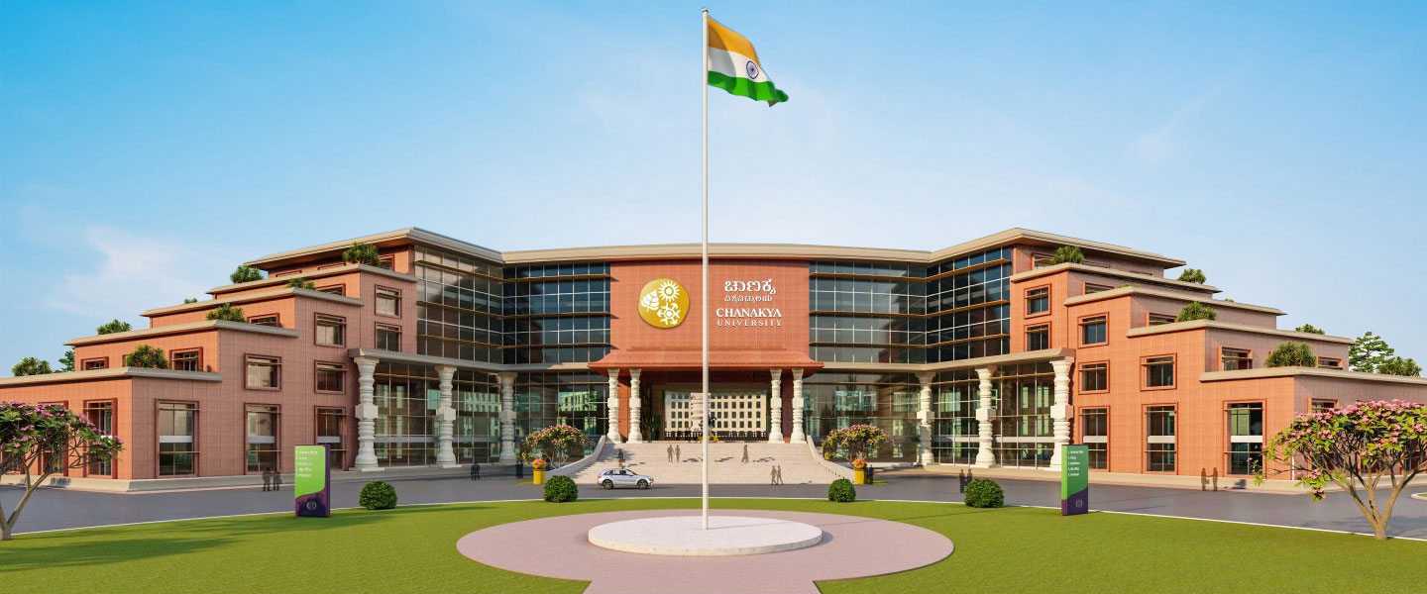

Code :
<!DOCTYPE html>
<html lang="en">
<head>
<meta charset="UTF-8" />
<meta name="viewport" content="width=device-width, initial-scale=1.0"/>
<title>Campus Navigation</title>
<link
rel="stylesheet"
href="https://unpkg.com/leaflet@1.9.4/dist/leaflet.css"
crossorigin=""
/>
<script
src="https://unpkg.com/leaflet@1.9.4/dist/leaflet.js"
crossorigin=""
></script>
<style>
* { box-sizing: border-box; margin:0; padding:0; font-family: Arial, sans-serif;}
body { background: #f0f4f8; padding: 20px; display:flex; justify-content:center; align-items:center; min-height:100vh;}
.container { display:flex; flex-wrap:wrap; width:100%; max-width:1200px; background:#fff; border-radius:20px; overflow:hidden; box-shadow:0 10px 25px rgba(0,0,0,0.15); position:relative;}

.login-section, .logo-section { flex:1 1 50%; padding:40px 30px; max-height:90vh; overflow-y:auto; background: rgba(255,255,255,0.95);}
.logo-section { text-align:center; display:flex; flex-direction:column; align-items:center; justify-content:center;}
.login-section img { width:34px; margin-bottom:20px;}
.login-section h2 { color:#1D3A5F; font-size:28px; font-weight:bold; margin-bottom:8px;}
.login-section p { color:#2A5980; font-size:14px; margin-bottom:20px;}
.login-section label { display:block; margin-bottom:5px; color:#1D3A5F; font-weight:bold;}
.login-section select { width:100%; padding:12px 15px; border-radius:25px; border:1px solid #c0d4f0; background: rgba(255,255,255,0.7); margin-bottom:20px; font-size:14px; color:#1D3A5F;}
.login-section button { width:100%; padding:12px; border:none; border-radius:25px; background:linear-gradient(to right,#3a86ff,#1c5ed6); color:#fff; font-size:16px; font-weight:bold; cursor:pointer; transition:0.3s;}
.login-section button:hover { opacity:0.9;}
.logo-section img { height:220px; margin-bottom:20px;}
.logo-section h1 { font-size:28px; font-weight:bold; margin-bottom:10px; color:#1A2E45;}
.logo-section h2 { font-size:22px; font-weight:600; color:#28a745; margin-bottom:10px;}
.logo-section p { font-size:14px; color:#3b82f6;}

/* Map Section */
#mapContainer { display:none; position:absolute; top:0; left:0; width:100%; height:100%; background:#fff; z-index:2000; }
#map { width:100%; height:100%; }
.back-button { position:absolute; top:20px; left:20px; z-index:2100; padding:10px 15px; background:#3a86ff; color:#fff; border:none; border-radius:8px; cursor:pointer;}
.back-button:hover { opacity:0.9;}
.route-info { position:absolute; bottom:20px; left:20px; z-index:2100; background:rgba(255,255,255,0.9); padding:10px 15px; border-radius:8px; box-shadow:0 5px 15px rgba(0,0,0,0.2); font-size:14px; color:#1D3A5F; max-width:300px;}
@media (max-width: 768px) {
.container { flex-direction:column; }
.login-section, .logo-section { flex:1 1 100%; }
#mapContainer { position:fixed; top:0; left:0; width:100%; height:100%; }
}
</style>
</head>
<body>

<div class="container" id="inputContainer">

<div class="login-section" id="loginSection">
<div>
<h2>Bot Brain</h2>
<p>Please enter your Start and End locations</p>
<hr style="border: 0; height: 2px; background: #3a86ff; margin: 10px 0;">
</div>

<form>
<label for="start">Start Location</label>
<select id="start">
<option value="13.2201951,77.7541421">Main Gate</option>
<option value="13.2213743,77.7551241">Gate 2</option>
<option value="13.2221283,77.7552384">ACADEMIC A</option>
<option value="13.2233225,77.7559227">ACADEMIC B</option>
<option value="13.2247972,77.7571941">Food Court</option>
<option value="13.2245171,77.7588691">Hostel 1</option>
<option value="13.2286181, 77.7583193">Volleyball Court</option>
<option value="13.228393,77.757574">Cricket Ground</option>
<option value="13.2244904, 77.7571404">Laundry</option>
<option value="13.2245579, 77.7591752">MART</option>
</select>

<label for="end">End Location</label>
<select id="end">
<option value="13.2201951,77.7541421">Main Gate</option>
<option value="13.2213743,77.7551241">Gate 2</option>
<option value="13.2221283,77.7552384">ACADEMIC A</option>
<option value="13.2233225,77.7559227">ACADEMIC B</option>
<option value="13.2247972,77.7571941">Food Court</option>
<option value="13.2245171,77.7588691">Hostel 1</option>
<option value="13.2286181, 77.7583193">Volleyball Court</option>
<option value="13.228393,77.757574">Cricket Ground</option>
<option value="13.2244904, 77.7571404">Laundry</option>
<option value="13.2245579, 77.7591752">MART</option>
</select>

<button type="button" onclick="navigate()">Navigate</button>
</form>
</div>

<!-- Logo Section -->
<div class="logo-section" id="logoSection">
<img src="banner.jpg" alt="">
</div>

</div>

<div id="mapContainer">
<button class="back-button" onclick="goBack()">Back</button>
<div id="map"></div>
<div id="routeInfo" class="route-info"></div>
</div>

<script>
let map, markers, routeLine;

function navigate() {
const startValue = document.getElementById("start").value.split(",");
const endValue = document.getElementById("end").value.split(",");

const startLatLng = [parseFloat(startValue[0]), parseFloat(startValue[1])];
const endLatLng = [parseFloat(endValue[0]), parseFloat(endValue[1])];

if (startLatLng.toString() === endLatLng.toString()) {
alert("Start and End locations cannot be the same!");
return;
}

document.getElementById("inputContainer").style.display = "none";
document.getElementById("mapContainer").style.display = "block";

if (!map) {
map = L.map('map').setView(startLatLng, 16);
L.tileLayer('https://{s}.tile.openstreetmap.org/{z}/{x}/{y}.png', {
maxZoom: 20,
attribution: '© OpenStreetMap'
}).addTo(map);
markers = L.layerGroup().addTo(map);
} else {
map.setView(startLatLng, 16);
}

markers.clearLayers();
if (routeLine) map.removeLayer(routeLine);

// Add markers
L.marker(startLatLng).addTo(markers).bindPopup("Start").openPopup();
L.marker(endLatLng).addTo(markers).bindPopup("End");

// Draw polyline (straight)
routeLine = L.polyline([startLatLng, endLatLng], {color: 'blue', weight:4}).addTo(map);

// Fit map bounds
map.fitBounds([startLatLng, endLatLng], {padding:[50,50]});

// Calculate distance in meters and convert to km
const distanceMeters = map.distance(startLatLng, endLatLng);
const distanceKm = (distanceMeters / 1000).toFixed(2);

// Optional estimated time (walking ~5 km/h)
const timeMinutes = Math.round((parseFloat(distanceKm) / 5) * 60);

// Update route info panel
document.getElementById("routeInfo").innerHTML = `
<strong>Start:</strong> ${document.getElementById("start").selectedOptions[0].text}<br>
<strong>End:</strong> ${document.getElementById("end").selectedOptions[0].text}<br>
<strong>Distance:</strong> ${distanceKm} km<br>
<strong>Est. Walk Time:</strong> ${timeMinutes} min
`;
}

function goBack() {
document.getElementById("mapContainer").style.display = "none";
document.getElementById("inputContainer").style.display = "flex";
if (routeLine) { map.removeLayer(routeLine); routeLine = null; }
document.getElementById("routeInfo").innerHTML = "";
}
</script>

</body>
</html>

Integration & Future Scope
The backend and frontend together create a dynamic, scalable, and user-friendly navigation system. Future enhancements could include indoor navigation, voice-based assistance, and AR-based directions.

